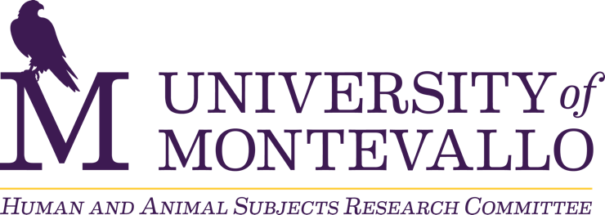

Research Application Submission Checklist

The Human and Animal Subject Research Committee (HASRC) conducts reviews of all research applications submitted by faculty, staff, and students in accordance with the review schedule.

To ensure that your application can be processed efficiently, please make sure you have completed the following steps before submitting your application.

- Faculty/staff researchers/mentors and student researchers must submit documentation of training related to the protection of human research participants.
  - After completing login/registration process:
    - Select: Human Subjects Research Course
    - Select: UM Faculty, Staff, & Student Researchers (Group).
  - After completing Human Subjects Research Course:
    - Download: CITI Training Completion Certificate
    - Save all certificates as a single document if there is more than one researcher on the research application.
- Prepare your research application.
- Prepare all questionnaires, surveys, interview questions, or other instruments that will be used to gather data. Save as a single file.
- Prepare informed consent document or initial page of online survey, if participants will provide informed consent electronically. Assent forms are also required for research involving minor participants.
- Prepare recruitment script that will be read to participants (if data will be collected in person) or email/online participant solicitation (if data will be collected electronically).
- Submit your research application. You will be prompted to attach the supporting files listed in steps 1-5.

If you need to amend an approved research application, prepare your research application amendment. Submit your research application amendment.

Please allow a minimum of fifteen business days for the committee to complete the review process.

If an adverse event or effect occurs as you are conducting your research, submit an adverse event form to twang@montevallo.edu within 24 hours of an adverse event or effect.

For additional information, please visit https://www.montevallo.edu/academics/human-and-animal-subjects-research/

