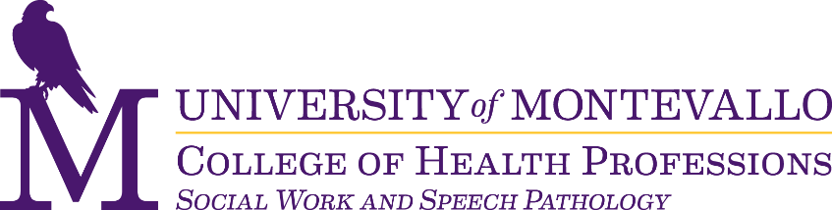

We are excited that you have chosen to apply to the Speech Language Pathology program at the University of Montevallo. We offer an exciting curriculum and a broad range of clinical opportunities. The department is committed to preparing students to become clinical leaders in the field of Speech Language Pathology. The curriculum emphasizes the problem-solving and critical thinking skills necessary to become strong clinical professionals capable of serving a varied client population.

Applications are to be submitted through CSDCAS at https://csdcas.liaisoncas.com/applicant-ux/#/login
- If you have, or will have, a completed Bachelor’s degree in Communication Science & Disorders, Speech-Language Pathology, or Speech/Hearing Sciences, you will apply to the M.S. SLP Traditional track on CSDCAS.
- If you have, or will have, a completed Bachelor’s degree in a field other than CSD, SLP, or Speech/Hearing Sciences, you will apply to the M.S. SLP Nonbackground track on CSDCAS (even those with some CSD coursework).

Application requirements for the Speech-Language Pathology Master’s program are:
- One (1) official transcript each from ALL colleges/universities attended.
Transcripts must be sent to:
CSDCAS Verification Department
PO Box 9113
Watertown, MA 02471
- Minimum GPA of 3.0 overall and a minimum GPA of 3.0 on the last 60 hours completed.
  - Applicants who do not meet the GPA minimums may still be considered for conditional admission if the cohort is not filled.
- Three (3) recommendation forms.
- CSD, SLP, or Speech/Hearing Sciences Majors: These forms are to be completed by faculty/staff members in CSD who directly taught, advised, or supervised the applicant.
  - Degree in a field not listed above: These forms are to be completed by faculty/staff members within the applicant's field of study who directly taught, advised, or supervised the applicant.
  - Any exceptions to the credentials of the reviewer must be preapproved by Dr. Edwards, Graduate Program Coordinator.
- Funding:
  - GA positions: Applicants must complete the GA application on CSDCAS if they want to be considered for one of the positions.
  - Funding: Limited funding opportunities are available to applicants. All applicants will be automatically considered for funding opportunities during the admissions process, without the need to complete additional applications.
- The University is unable to provide notification of missing application elements.

*To ensure that applications are processed on time, due to the high-volume processing demand in January for CSDCAS, it is strongly suggested that applications and documents be submitted 2-3 weeks before the January 15th deadline.

**While the University of Montevallo is not requiring an application fee for our program this year, CSDCAS does have fees for use of their services. Information about those fees can be found on CSDCAS’s webpage.
A personal interview may be required as part of the admissions process. The M.S. SLP program will begin contacting qualified applicants in February if an interview is warranted.
For more information regarding courses and degree requirements, please visit the M.S. SLP program webpage.
For information concerning financial aid, please contact Student Financial Services at (205) 665-6050.

If you experience problems or have questions, contact:
CSDCAS Customer Service: (617) 612-2030 or csdcasinfo@csdcas.org
Allison Thomas, Administrative and Graduate Program Assistant: (205) 665-6720 or athoma24@montevallo.edu

