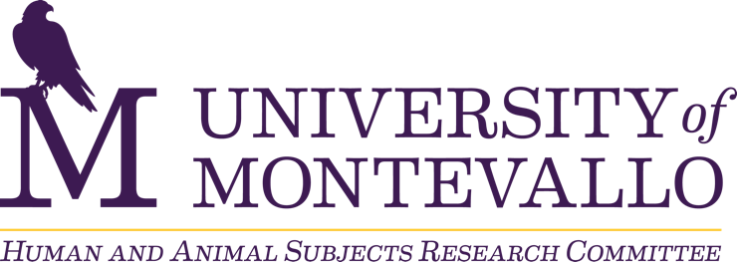

Review Schedule

Fall 2025 – Spring 2027

Date Range | Review Status
August 20, 2025 – December 5, 2025 | Reviewing applications
December 6, 2025 – January 6, 2026 | Not reviewing applications  - All applications submitted during this time frame will be reviewed when the Spring 2026 semester begins.
January 7, 2026 – April 24, 2026 | Reviewing applications
April 25, 2026 – August 18, 2026 | Not reviewing applications  - All applications submitted during this time frame will be reviewed when the Fall 2026 semester begins.
August 19, 2026 – December 4, 2026 | Reviewing applications
December 5, 2026 – January 10, 2027 | Not reviewing applications  - All applications submitted during this time frame will be reviewed when the Spring 2027 semester begins.
January 11, 2027 – April 30, 2027 | Reviewing applications

